IB LAB and TRN

- Please provide MSH.4.1 value
  - Test
  - Prod

- Will PID.3 ever repeat?
  - If so, how can the patient’s MRN be identified? Example (screenshot below): You can tell that PID-3 repeats because of the “~” character that separates each set of identifiers. You could say that the way to identify the MRN is to find the repetition where PID.3.5 is “MR”.
- Please provide translation tables for the following:
  - OBR.25 (result status) Final results only
Default Code (HIE) | Description (HIE) | Default Code (Source) | Description (Source)
A | amended
B | appended
C | corrected
F | final
P | preliminary | n/a | n/a

  - OBX.8 (abnormal flags) are an optional field.
    - Will you send a value in OBX.8?
    - If you are sending a value in OBX.8, please refer to CSS’s existing mapping list for abnormal flags below.
    - Can CSS use our existing mapping for abnormal flags?
      - (i.e., if you send us “HH” CSS will flag this as “Critically high”)

HL7 Value | Mapping
A | Abnormal
> | Off scale high
H | Above high normal
HH | Critically high
HU | Very high
AC | Anti-complementary substances
< | Off scale low
L | Below low normal
LL | Critically low
LU | Very low
B | Better
TOX | Cytotoxic substance present
DET | Detected
IND | Indeterminate
I | Intermediate
IB | Inducible Beta-lactamase/Susceptible
IE | Insufficient evidence
MS | Moderately susceptible (micro)
NEG | Negative
NR | Non-reactive
N | Normal
ND | Not Detected
NS | Non-susceptible
POS | Positive
QCF | Quality Control Failure
RR | Reactive
R | Resistant
D | Significant change down
U | Significant change up
S | Susceptible
SDD | Susceptible-dose dependent
SYN-R | Synergy - resistant
SYN-S | Synergy - susceptible
AA | Critically abnormal
VS | Very susceptible (micro)
WR | Weakly reactive
W | Worse
HM | Hold for Medical Review
C | Critical

  - OBX.11 (observation status)
Default Code (HIE) | Description (HIE) | Default Code (Source) | Description (Source)
A | amended
B | appended
C | corrected
F | final
P | preliminary | n/a | n/a

- For corrected/appended/amended results, can you resend all the result data in the message (not just the part of the result that was updated)? For example, if the final result message contained 3 OBX segments, those 3 OBX segments should be sent in the corrected message plus the corrected result (which might be a new OBX or NTE segment, or it might be a modification to the observation value in one of the original OBX segments).
- Please also ensure the following fields are populated
  - OBR.3 (filler order number/Accession number)
  - OBR.4 (universal service identifier)
- Will you ever generate messages when a report is made unavailable (a final result is deleted or cancelled, for example) and where the expectation is for (HIE) to delete the report as well? If so, please specify how to identify this in the message.
- Will you ever send Base64 encoded PDFs in OBX segments? If so:
  - Please provide at least 1 sample message
  - If the file is large, will that affect how it is sent in the OBX segment? For example, part of the Base64 encoded string might be in OBX.5.5 in multiple OBX segments and need to be combined to create a single, valid Base64 encoded string for a single PDF file. This requires custom development and might take time.

Additional Questions for clients sending MDMs:
- Are you going to send MDM^T11? If so, CSS treats MDM T11 as a hard delete; any documents sent with T11 message will be deleted from the InContext portal. Please refer to CSS ORU specification.

Additional Question For Microbiology and Pathology Lab results
- Are you able to send microbiology and/or pathology results as text (rather than discretely)? If not, please filter these messages from being sent to (HIE). We can receive either free text or PDF micro results. PDF micro results are preferred
- We advise against sending microbiology/pathology results (especially those containing cultures and susceptibilities) in discrete format because our system is not able to display this type of data in a clear and organized way to clinicians. We prefer to receive microbiology/pathology results in a free text or base64 PDF format. If free text or base 64 encoded PDF is not an option, we prefer that microbiology/pathology results are filtered out from sending to CSS. If this is not possible, please provide enough information so that we can filter out microbiology results on our side.
- CSS clarification on what it means by “free text”
  - Option 1: OBX segments where data type is FT and the contents of OBX-5.1 across all OBX segments combined are a text report formatted with line breaks and spacing
  - Option 2: NTE segments where the contents of NTE-3.1 across all NTE segments combined are a text report formatted with line breaks and spacing
  - Option 3: OBX segments where data type is ST or TX, OBX-3.1 and OBX-3.2 are identical for all OBX segments under that result grouping (i.e. for all OBX segments under the OBR segment), and the contents of OBX-5.1 across all OBX segments combined are a text report formatted with line breaks and spacing
    - Any OBX segment where data type is ST or TX and OBX-3.1 and OBX-3.2 are unique within that result grouping (i.e. for all OBX segments under the OBR segment) will be processed as discrete results and displayed under the Observations section in Health Records. See below:
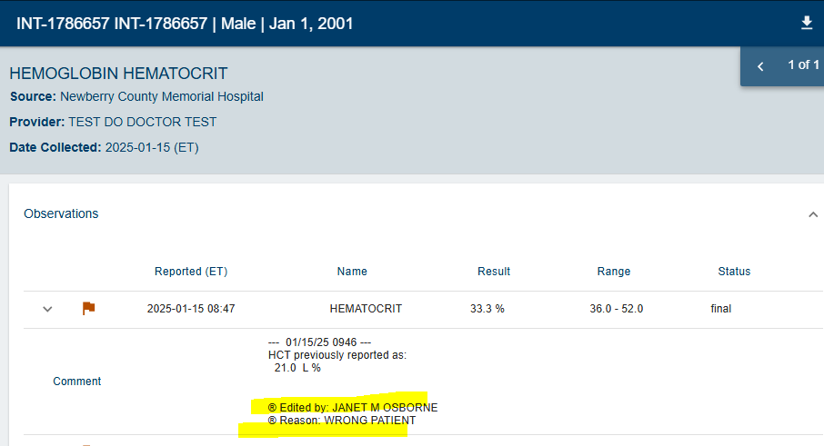
- each segment is processed onto its own line in the free text report
- free text could be contained within one segment. Line break characters are ~ and \.br\
- Free text results display under the Notes section in Health Records
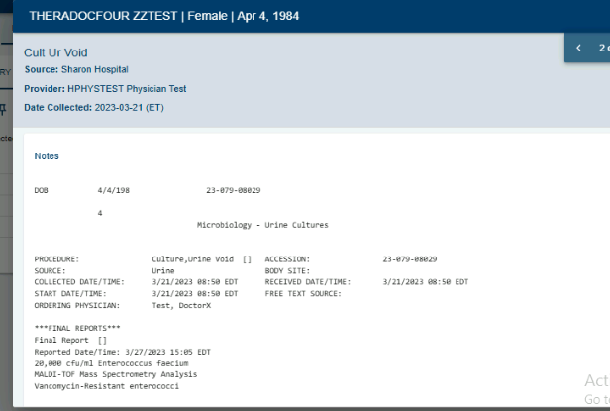

Good Sample Message

MSH|^~\&|CERNMILL|SH|||20230327150526||ORU^R03|Q1306206716T2105602037|T|2.3
PID|1|2062067822^^^Enterprise ID^CMRN|411042489^^^SH MRN^MRN||ZZTEST^THERADOCFOUR||19840404|F|||100 Reserve Rd^^Danbury^CT^06810^USA^H^^Fairfield|||||||11235246
PV1|1|I|2N^242^A^SH||||HPHYSTEST^Test^Physician^^^^^^VBMC External ID^PER^^^EXTERNAL ID^CD:259613463|||MED|||||||HPHYSTEST^Test^Physician^^^^^^VBMC External ID^PER^^^EXTERNAL ID^CD:259613463|||||||||||||||||||||||||||20230224162208
OBR|1|3644394809||MI9019^Cult Ur Void|||202303210850|||||||202303210850||H123466^Test^DoctorX^^^^^^VBMC External ID^PER^^^EXTERNAL ID^||||||202303271505||MICROBIOLOGY|F||1^^^202303201424^^S~
OBX|1|FT|MICC20050^Culture,Urine Void^^^^||DOB 4/4/198 23-079-08029\.br\\.br\ 4\.br\ Microbiology - Urine Cultures\.br\\.br\\.br\PROCEDURE: Culture,Urine Void [] ACCESSION: 23-079-08029\.br\SOURCE: Urine BODY SITE:\.br\COLLECTED DATE/TIME: 3/21/2023 08:50 EDT RECEIVED DATE/TIME: 3/21/2023 08:50 EDT\.br\START DATE/TIME: 3/21/2023 08:50 EDT FREE TEXT SOURCE:\.br\ORDERING PHYSICIAN: Test, DoctorX\.br\\.br\***FINAL REPORTS***\.br\Final Report []\.br\Reported Date/Time: 3/27/2023 15:05 EDT\.br\20,000 cfu/ml Enterococcus faecium \.br\MALDI-TOF Mass Spectrometry Analysis \.br\Vancomycin-Resistant enterococci\.br\\.br\\.br\***PRELIMINARY REPORTS***\.br\Preliminary Report []\.br\Reported Date/Time: 3/21/2023 09:23 EDT\.br\20,000 cfu/ml Gram Positive Cocci\.br\\.br\***SUSCEPTIBILITY RESULTS***\.br\ Entfaeci\.br\Antibiotic MIC Dilutn MIC Interp\.br\Ampicillin >=32 Resistant\.br\Ciprofloxacin >=8 Resistant\.br\Gentamicin Syn-S Susceptible\.br\synergy\.br\Levofloxacin >=8 Resistant\.br\Linezolid <=0.5 Susceptible\.br\Nitrofurantoin <=16 Susceptible\.br\Streptomycin Syn-S Susceptible\.br\synergy\.br\Tetracycline >=16 Resistant\.br\Vancomycin >=32 Resistant||||||F|||20230327150522

How it will display in the portal:

